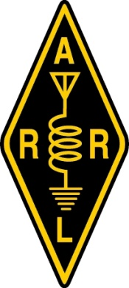
This year your
IARU HF World Championship
2025 Full Results
By Bob Raymond, WA1Z (bobraymondwa1z@gmail.com)

The best thing about contesting? Watching propagation change - hour by hour, sometimes minute by minute. The ionosphere is a very complex system! – Gary, AF8A
This year marks the 100th anniverary of the founding of the International Amateur Radio Union, which was established in 1925 at the International Amateur Congress in Paris. From the early days of shortwave research to today, the IARU has served as the international representative for ham radio. It has been instrumental in the development of amateur radio services across the world through its collaboration and consultation with the United Nations, International Telecommunications Union (ITU), and regional telecommuncations unions. A lot of the wall-to-wall activity we hear across the world on major DX contest weekends, such as the IARU HF World Championship, is thanks in large part to the tireless work of IARU personnel over the decades as amateur radio spread successfully across the world.
This year, the 40th annual IARU HF World Championship played its small role in the centennial celebration with 5,077 logs submitted from fifty-two ITU Zones, fifty-two Headquarters stations, Administrative Council members, and representatives from the three ITU Regions. Looking back at the inaugural IARU HF World Championship held in July 1986, this contest has come a long way in terms of popularity and is arguably enjoying its golden age today. In that first contest, 1,397 logs were submitted and just 16 IARU Headquarters stations participated (albeit, history records those teams got on the air with relatively short notice).
Propagation
The 2025 edition will not go down as having the best conditions. After enjoying better conditions last year, which benefited from a solar flux in the mid-230s, participants this year had hoped those elevated conditions might linger just a little longer, but were left lamenting what appears to be a solar cycle peak in the rearview mirror with many describing in their 3830scores.com posts conditions that were among the poorest they had experienced in years.

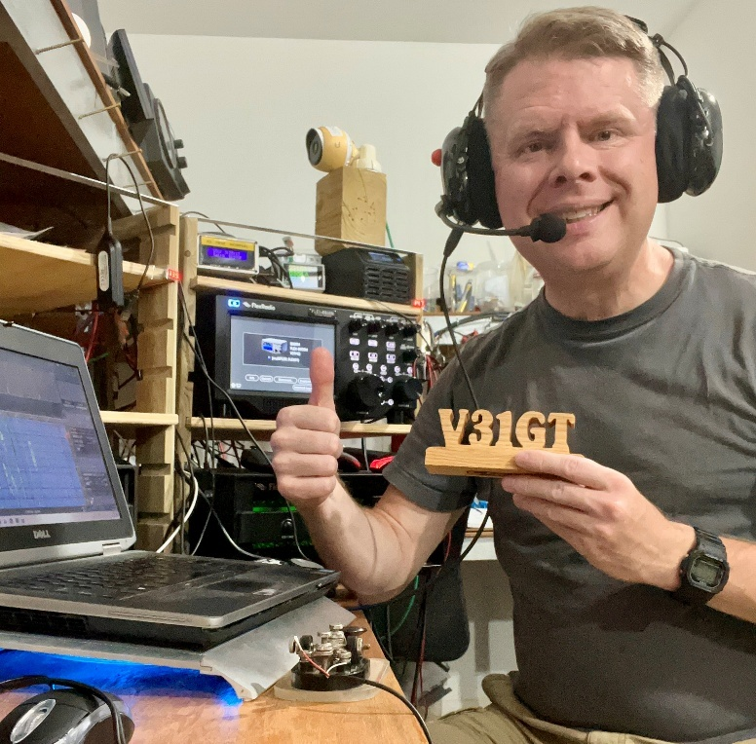
Josh, W9HT, operated part time from Belize as V31GT in the Single Operator Unlimited, Phone Only, High Power category (Photo courtesy of W9HT)
Larry, K4AB, echoed a common refrain by many, summarizing the weekend, succinctly: "this felt like contesting during a solar minimum."
However, the conditions we experienced this year were somewhat normal. In fact, looking back to the inaugural IARU HF World Championship in 1986, authors Robert Halprin, K1XA and Billy Lunt, KR1R, described this North American perspective in the results article published in the February 1987 edition of QST:
“At least on this side of the Atlantic, the HF Championship was essentially a two-band contest - 20 meters during the day and 40 at night. Conditions on those two bands were excellent. Contacts made on the other bands were limited, sort of like going through the motions, which is totally understandable based on the time of year and the lackluster conditions at this point in the sunspot cycle.”
While 1986 was in a deeper part of the sunspot cycle than we are today, this sounds familiar.
In 2025, impressions of 15-meter conditions certainly varied depending on geographic location. Stations located south of the major population areas of Europe and North America reported 15 and 20 meters were their most productive bands, but others who relied more on east-west paths, typically susceptible to higher absorption in the summer months, saw a significant reduction in propagation on 15 meters and shorter band openings in the evening on 20 meters.
With excellent 20-meter conditions across common paths of darkness in last year’s IARU HF, many contesters opted to sacrifice low band numbers and, perhaps, avoid the aural discomfort of summertime atmospheric noise in favor of quieter and more enjoyable conditions. This year, while propagation on 20 meters between some parts of the world occurred during the hours of darkness, there was a clear activity shift to 40 meters in the local evening hours.
Bill, K2PO, who led the West Coast Region in the Single Operator Unlimited, CW Only, High Power category from his station in Oregon, expected more opportunities on the higher bands to work Japan, stating in his post, “I expected 15 [meters] to be a top band for JA QSOS, but I logged only three QSOs there.”
Jim, VE7ZO, who finished very close behind Bill in the standings said, "on Saturday evening, 40 [meters] was notable in that, in spite of a small coincidental darkness between Vancouver Island and EU, I was able to work a number of the HQ stations and several single ops at their sunrise."
In the same region and category, Roberto, K6KM, who was chasing Bill and Jim while operating from W6SRR in San Jose, California, was left out of the marginal 40 meter path to Europe altogether, saying "[I worked] no [Europe] on 40m as we don't have much mutual darkness overlap with this side of the continent this time of the year."
Across North America, the high bands simply did not deliver this year. Further east in Michigan, Mike, NE8P, took conditions as a cue that it is time to plan ahead writing, “time to think about tuning up the lower band stuff!"
But there were still moments of joy. Jack, W6FB, who operated from his QTH in Louisiana said he was "amazed at how my 35-ft 80 meter dipole did on 40 [meters]. [I] worked several ZL (New Zealand) and VK (Australia) using it on 40 [meters] - a first for this QTH!"
We Wouldn’t Have As Much Fun Without These Folks
Before we get to the World and W/VE winners, it is important to recognize that while the IARU HF World Championship is a major worldwide contest that attracts thousands of operators around the world, it has some of the fewest multiplier opportunities of all the major DX contests. This can present a challenge if not enough people in the right locations get on-the-air.
ITU Zones are, in terms of surface area, the largest multipliers we have in contesting. As mentioned in the opening paragraphs, fifty-two ITU Zones were activated this year. When you combine ITU Zones with the number of “Special Station” multipliers (Headquarters, Administrative Council and ITU Region stations), there were only 108 potential multipliers on each band.
Here are two interesting data points:
- Sixty-seven percent of the multipliers we had a chance to work this year were activated by just 128 stations - only 2.5 percent of the total number of submitted logs.
- Forty-nine stations did Single Operator or Multioperator efforts in 15 ITU Zones that had 5 or fewer entries.
Along with acknowledging the dedicated operators behind the “special stations” later in the article, we’ll start by listing these operations as a thank you for facilitating the multiplier opportunities the rest of us enjoyed this year.
Operations from ITU Zones With 5 or Fewer Entries
MIX: Mixed Mode; CW: CW Only; PH: Phone Only; MS: Multioperator Single Transmitter; M2: Multioperator Two Transmitter; HP: Over 150W; LP: 150W or less; QRP: 5W or less;
ITU Zone | Category | Callsign | Score
1 | MSHP | KL5DX | 802,800
1 | SO-PH-HP | NL7V | 15,488
1 | SOU-CW-LP | KLØD | 1,221
1 | SO-MIX-LP | AL7JX | 266
1 | SOU-PH-HP | K1TAQ | 3
3 | SO-PH-HP | VE4SG | 58,344
3 | SO-CW-LP | VE5GC | 5,740
3 | SO-CW-LP | VE4IM | 1,584
3 | SO-MIX-LP | VA6RCN/VA5 | 1,170
3 | SO-PH-LP | VE4NOL | 68
17 | SO-PH-HP | TF2LL | 207,009
17 | SO-CW-HP | TF3W | 113,274
17 | SOU-PH-LP | TF3AO | 372
19 | SOU-MIX-HP | RZ1OK | 208740
19 | SO-CW-LP | UA1F | 128,576
19 | SO-CW-LP | R1BH | 5,680
20 | MSHP | RC9X | 145,750
20 | SO-CW-LP | RX9CC | 115,206
20 | SOU-CW-LP | RW9C | 70,400
20 | SO-CW-LP | R9XS | 47,235
20 | SO-CW-LP | UA9XBJ | 858
21 | MSHP | RC9J | 864,878
21 | SO-CW-LP | RA9JM | 18,720
23 | SOU-CW-LP | RØQC | 71,400
42 | SOU-MIX-HP | BGØDLA | 1,041,132
42 | M2LP | BYØAC | 179,634
42 | SO-CW-QRP | BG4SE | 25,752
42 | SO-CW-LP | BGØDKV | 1
46 | SO-CW-LP | TY5FR | 376,845
46 | SO-PH-LP | D44PM | 184,228
46 | SO-CW-LP | EL2DT | 36,718
48 | SO-MIX-HP | 5Z4VJ | 1,129,692
52 | SO-MIX-QRP | D2UY | 517,842
53 | MSHP | TO7K | 206,486
53 | SO-MIX-LP | 9J2FI | 156,900
53 | SO-CW-LP | 3B8HK | 1,045
53 | SO-PH-LP | 7Q7EB | 21
53 | SO-PH-LP | 5H8HZ | 16
57 | SOU-CW-HP | ZS1C | 244,620
57 | SO-MIX-LP | V55AF | 9,415
57 | SO-CW-LP | ZS5XT | 1,140
57 | SO-PH-LP | ZS6ELI | 108
57 | SO-PH-LP | 3DAØPA | 4
65 | SO-CW-LP | T3ØTTT | 124,072
66 | SO-CW-LP | ZD7TIM | 284,886
66 | SO-CW-HP | ZD7BG | 103,569
75 | SOU-MIX-HP | RD1A/MM | 45,322
75 | SOU-MIX-HP | VYØERC | 20,416
75 | SO-MIX-HP | DPØPOL/MM | 602

Single Operator
On the heels of last year’s impressive W/VE Mixed Mode, High Power victory from N6WIN’s station in ITU Zone 6, Dan, N6MJ, traveled east to New York to operate in person at N2QV – this time capturing 1st place World in the same category while holding off a fine challenge by Timo, OH1TM, operating as OG1F. Timo finished with the top European Single Operator score across all mode and power categories.

The battle for second place in the W/VE Mixed Mode, High Power standings was close between Pat, N9RV, in Montana and Nate, N4YDU, operating as AA4NC, in North Carolina. Each operator saw a drop of approximately 1,000 European QSOs compared to their similar efforts the previous year. Pat’s strategy from his competitive western station, however, is to also maximize normally favorable paths to Eastern Asia to make up for propagation advantages East Coast stations have to Europe. While Pat also experienced sub-par polar paths, he was able to combine just enough additional Asian QSOs along with an advantage of racking up 3-point QSOs to the East Coast on the high bands to inch-out a 41,000-point lead over Nate to earn the 2nd place spot.

Jan, DL3JAN, operating as DM7A, took a break from his usual CW Only effort, added a headset this year, and finished 1st place in the World Mixed Mode, Low Power category. John, W4IX, reactivated his station in South Carolina after an 8-year absence while living in Arizona. He assembled a make-shift station in a storage shed and with some antenna work, scratched his way to 1st place in the W/VE Mixed Mode, Low Power category.

Mika, D2UY, entered the Mixed Mode QRP category and finished 1st place in the World with a solid effort on 20, 15 and 10 meters. It turns out Mika is the first entrant in Mixed Mode QRP from Africa in the history of the contest!

There was another close battle in the Phone Only, High Power category for 1st place World between Marios, 5B4WN, who operated as C4W from Cyprus and Valery, EW5A, from Belarus. With both scores exceeding 1.4 million points, the final tally shows Marios with a mere 11,163-point advantage for 1st place, a difference of only approximately eleven intercontinental QSOs or two multipliers. Marios maximized his advantage to Europe across all bands with 93% of his QSOs coming from the nearby continent where each QSO is worth 5-points from the Asian island. Valery, whose contacts with Europe are not more than 3-points per QSO, nearly overcame a 2,400 QSO point deficit by taking a more balanced approach to the contest with greater emphasis on openings to North America and Asia; and securing sixty-three more multipliers.

Ramon, LU5HM, operating as LP1H, finished 3rd place overall in the Phone Only, High Power category, with the highest Single Operator score from South America in all categories.

Vlad, VE3JM, is a familiar presence in the CW Only, High Power category, often going toe-to-toe with Greg, W1KM, for the top spot in W/VE. Both gentlemen continued their rivalry this year with Vlad taking 1st place in the World with Bob, N6TV, operating as KH7Q from KH6YY’s QTH on Oahu, Hawaii, coming in 2nd place with the top Oceania Single Operator score. Greg, W1KM, finished in 3rd place World this year.

In another photo finish, top honors in the W/VE CW Only, Low Power category was decided by just 35 points between Mike, AD5A, our victor, and Vlad, VE3TM. Both put in full-time efforts and just a single QSO made the difference between first and second place.
Single Operator W/VE Division Records
MIX: Mixed Mode; CW: CW Only; PH: Phone Only; HP: Over 150W; LP: 150W or less; QRP: 5W or less
Division | Category | Callsign | Score
Pacific | SO-CW-QRP | W6YX (N7MH, op) | 123,851

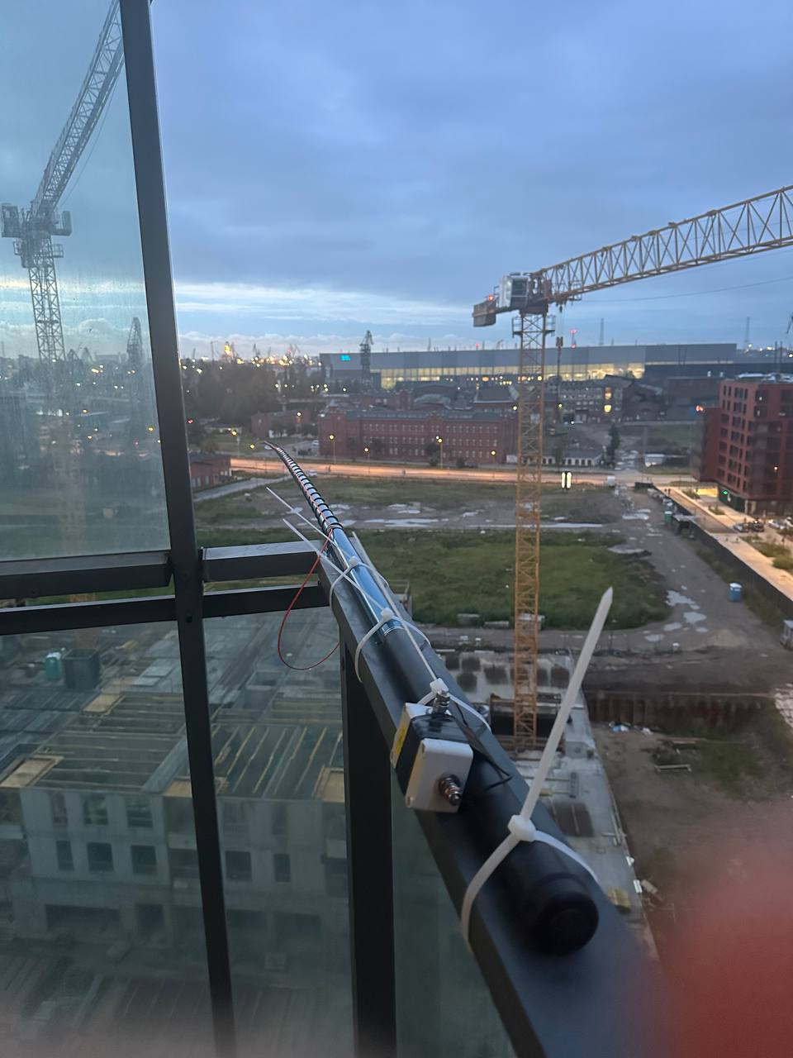
Contesting is not just about big antennas and full legal limit amplifiers. 2025 IARU HF World Championship was the first contest for Miroslaw, SQØY, who got on the air from his 10th story gazebo in Gdańsk, Poland. He made about 20 QSOs on 20 meter phone using 5 watts into this “Rybakov” antenna. (Photo courtesy of SQØY)
Single Operator Unlimited
Unlimited operators have the advantage of getting clues from station spots to gain a sense of where propagation opportunities exist at any moment. Theoretically, their logs serve as the prime source of information we can use to determine just how good, or bad, things were.
One of the common themes in post-contest reports this year was the slow start in the first several hours of the contest, particularly in North America where transatlantic propagation was at a premium. A comparison of Single Operator Unlimited logs from the northeastern portion of North America between last year’s contest and this year’s certainly bears that out.

While 10-meter propagation across east-west paths during the summer months in the northern hemisphere is always a challenge, during high sunspot years 15 meters can still be the go-to band earlier in the day for propagation between North America and Europe. Last year, the winner of the W/VE Single Operator Unlimited Mixed Mode category, Victor, VA2WA, whose 3.7 million point effort set a new W/VE record, enjoyed triple-digit rates on 15 meters in four of the first five hours of the contest. Milen, LZ5DB, who this year’s 1st place W/VE Mixed Mode, High Power winner, operated as ND3T from the K1LZ superstation in Maine. He worked a steady stream of stations on 15 meters for the first 10 hours of the contest, but never broke 100 QSOs in any hour and worked fewer than half the 5-point intercontinental QSOs Victor was able to make on the band last year. Despite making 600 more QSOs than Victor’s 2024 effort, overall, Milen fell 358k points short of the record thanks to limited propagation on 15 meters.

When considering the massive antenna systems at K1LZ and its location in the far-reaching corners of the Northeast Region, Milen’s challenges were only amplified for everyone else across North America. Two posts on 3830scores.com serve as good representations of the general sentiment from Single Operator Unlimited participants:

“[The] early hours here were a slog. The few EU stations heard here could not hear me; so it was primarily working US stations until the afternoon came around. Then things began to open up on 15 and 20M for me. As the day progressed, it became much easier to work non-US stations.” - Ted, WA3AER, operating CW Only, High Power.

“This contest started out sounding like the ARRL Sweepstakes with a simplified single-digit exchange. Only stateside stations were workable, and it took hours before I could get any DX in the log. As time progressed, the bands slowly opened up and provided solid contacts across the world.” – Bob KØRC, operating CW Only, Low Power.

Despite these less-than-ideal conditions, two powerhouse stations just outside of Europe still managed to break records in Single Operator Unlimited categories. Jozef, OM3GI, operating as CR3A from Madeira Island, set a record in the World Mixed Mode, High Power category with comfortable lead over Juan, EA8RM, in second place. Sergii, 5B4AMM, operating as P3X in Cyprus, set a new world record in CW Only, High Power. These stations exist in two general “sweet spots,” just far enough outside of Europe to be able to work stations on just about every band.

In the Mixed Mode, Low Power category, Laszlo, HA8QZ, operating as HG5D, finished 1st place in the World. Ninety-eight percent of his QSOs were on CW, serving as his winning formula in tough conditions for low power operation. Second and third place finishes come from South America where Soni, PY1NX, operating as PS2T, took advantage of some 10-meter propagation to Europe in the early hours of the contest, which ended up being the difference maker in a close battle with Yuri, N2TTA. Yuri operated from Trinidad and Tobago as 9Z4BM. John, WJ1U, who recently got back on the air after a 25-year period of inactivity, is this year’s W/VE Mixed Mode, Low Power winner.

Szűcs, HA9AX, operating as HA9A, is this year’s World Mixed Mode, QRP champion.

Gyuri, HA5JI, extended appreciation in his 3830scores.com post to Adam, OM2ADM, as they raced each other for 1st place in the World Phone Only, High Power category for participating in the Contest Online Scoreboard. They enjoyed keeping an eye on each other’s score postings. Gyuri said, “Thank you to everyone who participated in this contest. Special thanks to OM2ADM, with whom I had the opportunity to race at the front.”

Gawain, NØGJW, is the W/VE champion in the Phone Only, High Power category operating as NJ4P in Tennessee.

Alex, EA4HPY, operating as EE4M, finished 1st place in the World Phone Only, Low Power category. Art, N3AAA, had the top score in the W/VE Phone Only, Low Power category.

Didier, FY5FY, set a new record in the Phone Only, QRP category on his way to a 1st place finish in the World.

In the CW Only categories, Sergii, P3X, set a new world record in the High Power category while Charles, K3WW, operated from the N2SR station running away with the 1st place title in W/VE and 5th place overall in the World.

Gator, N5RZ, took 1st Place in the W/VE CW Only, Low Power category which was also good enough for a 6th place finish in the World standings.

Oliver, OMØRX, repeated his results from last year as the top Single Operator QRP score in the World while operating in the CW Only, QRP category from his 100% off-the-grid, solar-powered tiny home. Al, W1FJ, took top honors in W/VE CW Only, QRP.
New Single Operator Unlimited World Records
MIX: Mixed Mode; CW: CW Only; PH: Phone Only; HP: Over 150W; LP: 150W or less; QRP: 5W or less
Category | Callsign |  |  | Score
SOU-MIX-HP | CR3A (OM3GI, op) |  |  | 7,523,664
SOU-PH-QRP | FY5FY |  |  | 445,260
SOU-CW-HP | P3X |  |  | 6,369,160
New Single Operator Unlimited Continental Records
MIX: Mixed Mode; CW: CW Only; PH: Phone Only; HP: Over 150W; LP: 150W or less; QRP: 5W or less
Continent |  | Category | Callsign |  | Score
Africa |  | SOU-MIX-HP | CR3A (OM3GI, op) |  | 7,523,664
Maritime Mobile |  | SOU-MIX-HP | RD1A/MM |  | 45,322
South America |  | SOU-MIX-LP | PS2T (PY1NX, op) |  | 1,074,610
South America |  | SOU-MIX-QRP | PY2NDX |  | 11,550
Africa |  | SOU-PH-LP | EA8DGI |  | 242,141
Europe |  | SOU-PH-LP | EE4M (EA4HPY, op) |  | 1,332,840
Europe |  | SOU-PH-QRP | YO8WW |  | 352,170
South America |  | SOU-PH-QRP | FY5FY |  | 445,260
Asia |  | SOU-CW-HP | P3X |  | 6,369,160
Oceania |  | SOU-CW-HP | VL2A (VK2IM, op) |  | 1,571,110

New Single Operator Unlimited W/VE Division Records
MIX: Mixed Mode; CW: CW Only; PH: Phone Only; HP: Over 150W; LP: 150W or less; QRP: 5W or less
Division | Category | Callsign | Score
New England | SOU-MIX-HP | ND3T (LZ5DB, op @K1LZ) | 3,403,552
Midwest | SOU-MIX-LP | NØRC | 110,141
Southeastern | SOU-MIX-QRP | K3TW | 97,600
Southwestern | SOU-MIX-QRP | WQ6X | 46,909
Canada | SOU-MIX-QRP | VE3BFU | 441
Delta | SOU-PH-HP | NJ4P (NØGJW, op) | 493,392
Hudson | SOU-PH-HP | KE2AY | 410,495
Atlantic | SOU-PH-LP | N3AAA | 117,100
Northwestern | SOU-CW-HP | K2PO | 933,583
West Gulf | SOU-CW-LP | N5RZ | 829,326
Multioperator, Single Transmitter
WRTC 2026 Youth Team Leader, Willow, W7WLW, traveled to visit George, K5TR, to form a potent two-person team to win 1st Place W/VE. George reports in his 3830scores.com report, “[Willow] did CW only and I did SSB and some CW. While it was not planned, I used one radio and she used the other all weekend. Turns out that we each made about half of the total contacts.”
Ray, K9RS, has been forming multioperator teams in IARU HF from his Delaware QTH for a few years now, improving to 2nd place W/VE this year.
Valery, EW6W, and Sergey, EU1A, teamed up as CQ9A in Portugal and completed a decisive 1st place finish in the world. The team from RM9A finished as the top Asian team in a close race with UP2L.
Multioperator, Two Transmitter, Low Power
Now in its fourth year as an official category, Multioperator, Two Transmitter, Low Power affords teams the ability to operate a similar format found in the World Radiosport Team Championship (WRTC) event held every four years. While WRTC teams are two-person partnerships, teams in this category can have an unlimited number of operators. Even so, we often find WRTC veterans and hopefuls using this category as a chance to operate with teammates and test equipment for the next event. The next edition of WRTC will be hosted in United Kingdom in 2026.
Bud, AA3B, one of fourteen North American team leaders scheduled to compete in WRTC 2026, traveled with teammate, John, W2GD, to his usual contesting stomping ground in Aruba to operate as P44W with the express purpose of getting in some operating time together. They were rewarded with a 1st place finish in the World.
The six-man team at HG7T finished 2nd place overall with the top European score. Close behind in 3rd place was a foursome of WRTC veterans, Suad, DK6XZ; Winfried, DK9IP; Philippe, LX2A; and Bernd, VK2IA, operating as LX7I.
Ken, K6LA, and Ron, VE3AT, two other WRTC 2026 hopefuls, met at Ken’s contest QTH on Prince Edward Island, operating at VY2TT and finishing 1st place in W/VE. When Ken asked Ron for a highlight of the weekend Ken could add to their 3830scores.com post, Ron replied, “the lobster dinner Thursday night.”
New Multioperator, Two Transmitter, Low Power
Continental Records
Continent | Callsign | Score
North America | WP3C | 1,847,968
Oceania | 7I1I | 193,450
South America | P44W | 3,401,508

New Multioperator, Two Transmitter, Low Power
W/VE Division Records
Division | Callsign | Score
Northwestern | K7BTW | 64,965

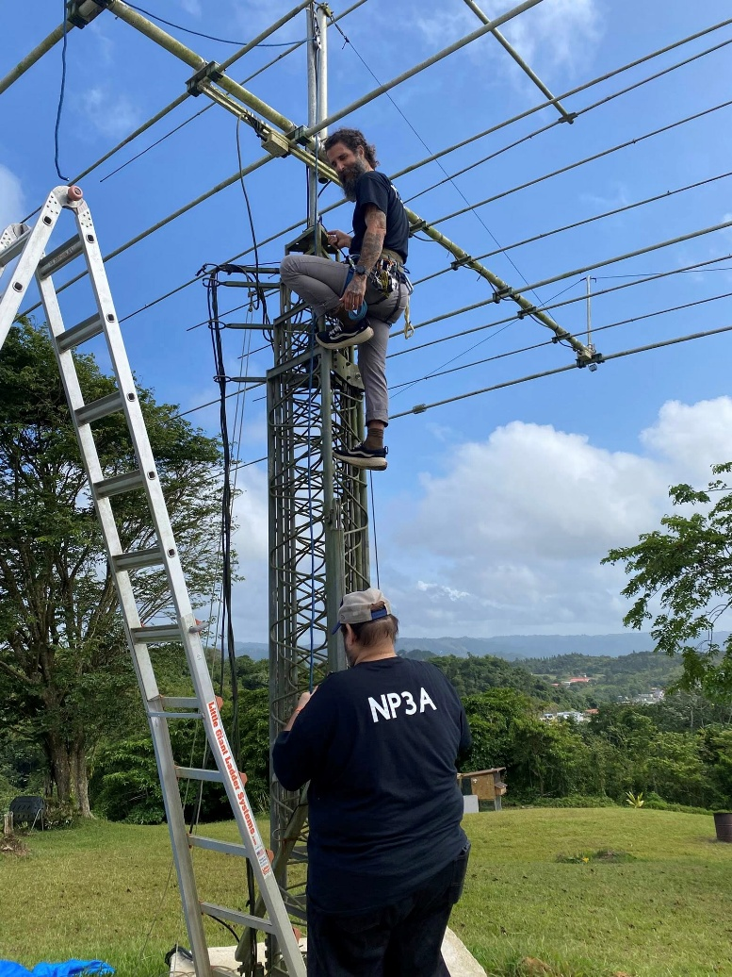
Eric, NP3A, and Manu, WP4TZ, getting the KP3J station ready for their Multioperator, Two Transmitter, Low Power effort as WP3Z from Aibonito, Puerto Rico. (Photo courtesy of Team WP3Z)
Headquarters and IARU Special Stations
The long-standing rivalry among the German (DARC), French (REF) and Spanish (URE) teams lives on for another year as the incumbent three-time repeat champions at DAØHQ (DARC) were ousted this year in an incredibly tight race in the final scores. DARC fell to third place as TMØHQ took first place.
W1AW (ARRL) HQ operations were performed from Puerto Rico for the very first time in the history of the contest. Led by Angel, WP3GW, who is the Public Information Coordinator for the ARRL Puerto Rico Section, Edgardo, KP3B; Jose, KP4JRS; Bo, NP3F; Oz, KP3N; Jose, NP4ET; Israel, KP4PUA; Carlos, NP4L; and Anthony, WP4I teamed up to make 3,245 QSOs.

The NU1AW operation representing the International Secretariat (IARU) were held at the ARRL Headquarters’ Hiram Percy Maxim Memorial Station (W1AW) in Connecticut. The team consisted of a mixture of ARRL staff and guests: Rich, K1CC; Audrey, KM4BUN; Jack, KM4ZIA; Paul, N1SFE; Conrad, N2YCH; Max, N4ML; Joe, NJ1P; John, W1DRF; and Bart, W9JJ.

IARU Headquarters Stations
Call | Score
TMØHQ | 19,194,670
EDØHQ | 18,987,246
DAØHQ | 18,748,935
9AØHQ | 18,576,960
II#HQ | 18,270,259
SNØHQ | 17,160,000
S5ØHQ | 16,510,280
GR2HQ | 14,849,380
YTØHQ | 14,804,092
LZØHQ | 13,847,532
OEØHQ | 10,967,686
SK9HQ | 10,145,520
OH1HQ | 9,245,097
YRØHQ | 9,211,752
OPØHQ | 8,496,852
HGØHQ | 8,360,422
E7HQ | 7,661,017
OZ1HQ | 7,064,194
HB9HQ | 6,557,019
R#HQ | 3,744,312
A6ØHQ | 3,520,188
B#HQ | 3,104,880
8N#HQ | 3,062,718
LT4RCA | 2,939,520
EIØHQ | 2,792,088
Z3ØHQ | 2,174,144
W1AW/KP4 | 2,050,242
ER7HQ | 1,917,092
DXØHQ | 1,573,746
ZL6HQ | 1,520,544
Z6ØHQ | 1,340,739
ES9A | 1,101,870
PJ2HQ | 880,384
3V8HQ | 879,874
UN1HQ | 851,599
OA4O | 805,335
V55HQ | 713,980
E2HQ | 660,240
VA3RAC | 556,640
CE3AA | 510,080
NU1AW | 466,137
HBØHQ | 367,131
HZØHQ | 286,172
EX9HQ | 228,174
CS5HQ | 212,410
HC2GRC | 187,680
HLØHQ | 164,280
OY1CT | 79,900
CX1AA | 60,804
VR2HK | 40,424
VK3WIA | 1,156
ZS9HQ | 42
IARU Administrative Council Stations
SM6EAN | 1,053,711
W5ZN | 578,250
VE6SH/7 | 57,660
IARU R1
IV3KKW | 1,990,326
DJ3HW | 419,950
HB9JOE | 196,808
IARU R2
VE3YV | 3,432
IARU R3
JA1CJP | 135,783
VR2XMC | 15

NOTE: # = Multiple stations in a single HQ operation, using call signs with different numbers in the prefix.
Thanks to the World Wide Radio Operators Foundation (WWROF, www.wwrof.org) for providing the log-scoring for the HQ station competition.
Oh Well, It Was Still Fun…
While we can chalk up this contest as a bit forgettable given the conditions, it’s still important to remember how much has changed in 40 years. The top Single Operator scores in W/VE and World in 1986 by Steve, N2IC and Jorge, LU8DQ (operating as AZ8DQ), respectively, didn’t come close to a million points. Neither broke 1,500 contacts.

Today, IARU HF World Championship remains as popular as ever. More than 4,000 log entries have been submitted every year since 2012 – and this year is the third consecutive year we’ve received more than 5,000 entries.

Join the fun in the 41st IARU HF World Championship starting at 1200z on July 11, 2026. With the excitement surrounding World Radiosport Team Championship 2026, we expect another banner year.

Disturbed conditions will not stop us!
Top Ten Scores
United States and Canada |  |  | World |  |  | United States and Canada |  |  | World
Single Operator |  |  |  |  |  | Single Operator Unlimited
Mixed-Mode, High Power |  |  |  |  |  | Mixed-Mode, High Power
N6MJ | 2,665,752 |  | N6MJ | 2,665,752 |  | ND3T (LZ5DB, op @K1LZ) | 3,403,552 |  | CR3A (OM3GI, op) | 7,523,664
N9RV | 1,489,012 |  | OG1F (OH1TM, op) | 2,344,448 |  | K3MM | 921,400 |  | EA8RM | 4,413,312
AA4NC (N4YDU, op) | 1,448,258 |  | UW5Y (US2YW, op) | 1,859,520 |  | W1GD | 908,725 |  | HA3NU | 3,714,095
K4ZW | 1,337,504 |  | N9RV | 1,489,012 |  | W3PU (KO8SCA, op) | 873,942 |  | ND3T (LZ5DB, op @K1LZ) | 3,403,552
KM7W (KL9A, op) | 1,305,447 |  | AA4NC (N4YDU, op) | 1,448,258 |  | K4AB | 790,224 |  | EA8BW | 2,819,790
K6XX | 1,003,944 |  | K4ZW | 1,337,504 |  | K9OM | 564,927 |  | UP4L (UN7LZ, op) | 2,209,218
K5WA | 1,003,844 |  | KM7W (KL9A, op) | 1,305,447 |  | KA3DRR (@N6WT) | 441,490 |  | YT9X (YU1ZZ, op) | 2,144,720
K4PV | 316,404 |  | 5Z4VJ | 1,129,692 |  | AB2E | 424,205 |  | PW2F | 2,076,975
WR5O | 312,825 |  | K6XX | 1,003,944 |  | K3MD | 319,030 |  | R9MM | 1,876,815
N2IC | 304,212 |  | K5WA | 1,003,844 |  | W8MJ | 301,884 |  | PY4BZ | 1,822,618
Mixed-Mode, Low Power |  |  |  |  |  | Mixed-Mode, Low Power
W4IX | 475,115 |  | DM7A (DL3JAN, op) | 1,113,088 |  | WJ1U | 494,460 |  | HG5D (HA8QZ, op) | 1,769,353
N8II | 245,826 |  | PY2NY | 829,794 |  | WN4AFP | 192,874 |  | PS2T (PY1NX, op) | 1,074,610
N8PE | 148,082 |  | CT7BJG | 729,492 |  | NE9U | 181,366 |  | 9Z4BM (N2TTA, op) | 1,065,750
K5ZD | 109,592 |  | W4IX | 475,115 |  | W6FB | 118,655 |  | LZ8R | 1,023,132
N1NQD | 80,348 |  | SP2GMA | 306,696 |  | NØRC | 110,141 |  | OK6Y (OK2PTZ, op) | 951,300
KX4UI | 67,067 |  | UT3SO | 300,384 |  | WA2JQK | 100,005 |  | EU2F | 944,750
KD2TT | 64,152 |  | JS1OYN | 294,441 |  | NI1Q | 74,208 |  | PI4DX (PA3EVY, op) | 922,988
KA2FIR | 64,070 |  | UA6GO | 289,230 |  | KØKX | 70,210 |  | IO8O (IK8UND, op) | 900,232
KØEA | 61,270 |  | UF5A | 288,900 |  | NV3K | 62,605 |  | SP9XCN | 882,944
WA5LFD | 43,364 |  | HA1RJ | 258,579 |  | WA4IPU | 56,376 |  | UR6EA | 839,219
Mixed-Mode, QRP |  |  |  |  |  | Mixed-Mode, QRP
 |  |  | D2UY | 517,842 |  | K3TW | 97,600 |  | HA9A (HA9AX, op) | 745,290
 |  |  | HA5BA | 258,132 |  | WQ6X | 46,909 |  | YU1LM | 133,376
 |  |  | IZ3NVR | 132,225 |  | K8ZT | 6,020 |  | DDØVS | 119,126
 |  |  | 9A2EY | 84,102 |  | VE3BFU | 441 |  | K3TW | 97,600
 |  |  | UY7LM | 55,530 |  |  |  |  | HA6KG | 94,010
 |  |  | 7K1CPT | 51,921 |  |  |  |  | SP3EMA | 71,508
 |  |  | HB9EGA | 41,118 |  |  |  |  | PE2K | 58,065
 |  |  | ED3Q (EA3O, op) | 39,644 |  |  |  |  | WQ6X | 46,909
 |  |  | SP4LO | 38,675 |  |  |  |  | UX9Q (UR9QQ, op) | 44,032
 |  |  | JH7UJU | 37,989 |  |  |  |  | DJ3EI | 30,750
Phone Only, High Power |  |  |  |  |  | Phone Only, High Power
N1UR | 510,138 |  | C4W | 1,478,830 |  | NJ4P (NØGJW, op) | 493,392 |  | HA5JI | 2,326,784
W6AFA | 199,186 |  | EW5A (EW8ADX, op) | 1,467,667 |  | KE2AY | 410,495 |  | OM2ADM | 2,097,030
KE8FT | 89,928 |  | LP1H | 1,303,120 |  | VE9CF | 348,192 |  | OR1X | 1,776,600
KG1E | 70,122 |  | RA3OA | 1,272,240 |  | VE2NTT | 298,606 |  | EA1L | 1,622,985
VE4SG | 58,344 |  | TI1K (TI5CDA, op) | 1,093,328 |  | NA4DA | 172,788 |  | UZ7C (UT9CZ, op) | 1,549,308
VA3ZNQ | 31,257 |  | R3RZ | 980,277 |  | VE2CSM | 151,226 |  | OT7Q | 1,420,826
N4MM | 23,698 |  | S51CK | 811,832 |  | AEØMO | 139,480 |  | IK3UNA | 1,349,700
KQ4ZIO | 23,427 |  | F5LIW | 563,012 |  | W3FR | 72,924 |  | SN7D (SQ7D, op) | 1,304,292
K9MWM | 16,452 |  | OG7Z (DL4SVA, op) | 526,038 |  | W9NZ | 70,104 |  | PE1T | 1,113,832
KC2MBV | 14,522 |  | KP4PK | 523,528 |  | W4EEY | 67,462 |  | IKØPHY | 1,036,902
Phone Only, Low Power |  |  |  |  |  | Phone Only, Low Power
VE9CZ | 139,686 |  | CT2HOV | 572,125 |  | N3AAA | 117,100 |  | EE4M (EA4HPY, op) | 1,332,840
W9TCV | 53,664 |  | SN7T (SQ7OTK, op) | 444,325 |  | VA3IDD | 63,848 |  | HGØR (HAØNAR, op) | 922,523
KF8N | 50,692 |  | PY2UD | 419,220 |  | AC5O | 37,417 |  | PP1WW | 502,830
NL7WA | 44,672 |  | F4WDL | 319,365 |  | NQ9N | 31,533 |  | EW7B | 423,512
VE2IAA | 41,090 |  | IW2JWG | 251,515 |  | W4GB | 28,770 |  | UA3BL | 384,237
W2JV | 40,376 |  | YV4AW | 215,922 |  | W8TB | 28,251 |  | S52OT | 351,378
KC2QVD | 23,280 |  | OE6HLF | 193,970 |  | KC1QEM | 26,048 |  | HA1BB | 347,772
W8LYO | 21,186 |  | D44PM | 184,228 |  | KD9YOO | 19,027 |  | LY5GT | 288,225
N1GNF | 19,530 |  | OK6AB | 171,201 |  | N7MZW | 18,240 |  | LZ2ZY | 273,315
KS2G | 19,352 |  | DL3RC | 155,532 |  | AB5NX | 18,090 |  | EA8DGI | 242,141
Phone Only, QRP |  |  |  |  |  | Phone Only, QRP
W6QU (W8QZA, op) | 9,720 |  | ES6RW | 165,204 |  |  |  |  | FY5FY | 445,260
 |  |  | IZ4AIF | 65,653 |  |  |  |  | YO8WW | 352,170
 |  |  | SQ3RAX | 28,490 |  |  |  |  | HG6V (HA6IHA, op) | 136,655
 |  |  | 9A4OP | 20,418 |  |  |  |  | HG6K (HA6AK, op) | 126,228
 |  |  | DG7DBM | 14,848 |  |  |  |  | MW7FON | 17,536
 |  |  | DL5EC | 13,671 |  |  |  |  | DHØGDS | 16,835
 |  |  | IV3LNQ | 10,600 |  |  |  |  | SP5DNA | 11,058
 |  |  | W6QU (W8QZA, op) | 9,720 |  |  |  |  | YO8OLY | 5,957
 |  |  | E72BE | 6,838 |  |  |  |  | LZ1VCT | 5,109
 |  |  | GW5GDP | 6,264 |  |  |  |  | EI8LC | 1,530
CW Only, High Power |  |  |  |  |  | CW Only, High Power
VE3JM | 1,890,114 |  | VE3JM | 1,890,114 |  | K3WW | 2,097,048 |  | P3X | 6,369,160
W1KM | 1,513,377 |  | KH7Q (N6TV, op @KH6YY) | 1,652,168 |  | K9CT | 1,331,003 |  | HG8R (HA8JV, op) | 3,053,750
WXØB (AD5Q, op) | 1,192,779 |  | W1KM | 1,513,377 |  | WIØWA (WØAAE, op) | 1,010,240 |  | OM8CW | 2,192,139
NA8V | 1,031,600 |  | R3ZZ | 1,491,780 |  | K2PO | 933,583 |  | CT3KN | 2,189,640
WØUA | 973,440 |  | KP2M (KT3Y, op) | 1,413,081 |  | VE7ZO | 903,621 |  | K3WW | 2,097,048
K6NA | 775,443 |  | OM2X (OM2XW, op) | 1,259,690 |  | WO4O | 881,920 |  | OL8R | 2,078,880
VE7UF (VE7JH, op) | 666,666 |  | WXØB (AD5Q, op) | 1,192,779 |  | W8FJ | 844,038 |  | R8TT | 1,975,041
K5PI | 636,728 |  | NA8V | 1,031,600 |  | N3AD | 791,538 |  | HG3N (HA3LN, op) | 1,734,042
W3RJ | 511,700 |  | WØUA | 973,440 |  | W1UE | 753,468 |  | EU8U | 1,726,340
NT6Q (N5ZO, op @WA6TQT) | 471,410 |  | K6NA | 775,443 |  | N2PP | 752,500 |  | VL2A (VK2IM, op) | 1,571,110
CW Only, Low Power |  |  |  |  |  | CW Only, Low Power
AD5A | 693,660 |  | 4Z4AK | 1,547,888 |  | N5RZ | 829,326 |  | UN4Q | 1,928,308
VE3TM | 693,625 |  | OM3RM | 1,183,695 |  | N4AO (WC4E, op) | 590,640 |  | LY5W | 1,717,144
K1VUT | 429,156 |  | OM7K (OM7RU, op) | 884,304 |  | N2YO | 457,104 |  | HA7I (HA7JTR, op) | 1,318,340
N7VM | 420,679 |  | AD5A | 693,660 |  | NJ3K | 303,676 |  | HA7UI | 1,053,905
VA3SP | 310,853 |  | VE3TM | 693,625 |  | K2KW | 260,429 |  | 4U1A (YL2QN, op) | 1,030,864
WJ9B | 213,930 |  | RU9AC | 619,382 |  | KØAD | 221,667 |  | N5RZ | 829,326
W1NN | 184,140 |  | JA6GCE | 567,264 |  | WA2LMC | 217,175 |  | 9A1AA | 801,762
WB4TDH | 181,944 |  | SO5CW (DJ5CW, op) | 560,529 |  | W3KB | 203,580 |  | DA3M (DL3UB, op) | 778,044
KV8Q | 131,882 |  | RA3YDA | 494,273 |  | KC9EE | 200,367 |  | RW4S (RU4SS, op) | 776,272
VE3FH | 125,271 |  | UA9AT | 455,880 |  | AB9YC | 177,388 |  | RK9A | 693,672
CW Only, QRP |  |  |  |  |  | CW Only, QRP
W6YX (N7MH, op) | 123,851 |  | HA5PP | 404,890 |  | W1FJ | 112,548 |  | OMØRX | 1,117,240
N5ER | 79,135 |  | HG6C (HA6IAM, op) | 225,207 |  | KJ5T | 20,458 |  | UR2Y (USØYW, op) | 923,490
K8CN | 65,968 |  | LZ2RS | 197,127 |  | NB1U | 3,922 |  | HG6O (HA6OA, op) | 585,690
NU4B | 26,752 |  | OK6OK | 189,792 |  | KD8JDC | 1,674 |  | S52P | 342,496
K4YJ | 26,182 |  | DL1JDQ | 163,325 |  |  |  |  | W1FJ | 112,548
K7HBN | 21,197 |  | W6YX (N7MH, op) | 123,851 |  |  |  |  | PAØRDT | 70,434
N3CZ | 18,612 |  | N5ER | 79,135 |  |  |  |  | G4ZFE | 68,476
N4NM | 18,592 |  | K8CN | 65,968 |  |  |  |  | DL1EFW | 62,271
NQ2W | 2,860 |  | R6ZF | 65,682 |  |  |  |  | IK3TZB | 58,206
K1TW | 2,280 |  | US5VX | 64,311 |  |  |  |  | OM/UT2WW | 43,016
Multioperator, Single Transmitter, High Power |  |  |  |  |  | Multioperator, Two Transmitter, Low Power
K5TR | 1,649,174 |  | CQ9A | 7,538,416 |  | VY2TT | 1,993,050 |  | P44W | 3,401,508
K9RS | 1,305,500 |  | E7DX | 4,360,912 |  | N9NB | 1,071,840 |  | HG7T | 3,300,204
K8AZ | 1,190,952 |  | RM9A | 4,355,208 |  | NN3W | 977,882 |  | LX7I | 3,026,985
WD6T | 1,109,934 |  | UP2L | 4,239,277 |  | ND8DX | 329,420 |  | DRØW | 2,118,753
N7DX | 945,659 |  | RT4F | 3,821,664 |  | WG3J | 311,234 |  | VY2TT | 1,993,050
AD4ES | 744,462 |  | 4X1DX | 3,069,174 |  | W3ZGD | 227,404 |  | LY4L | 1,943,667
K3AJ | 730,584 |  | OK7O | 2,677,320 |  | W1FM | 186,333 |  | G1A | 1,924,317
W2A | 716,289 |  | HG6N | 2,593,836 |  | WA2QAU | 137,648 |  | YL4U | 1,877,841
KD1MC | 713,368 |  | DD2D | 2,333,804 |  | K8LG | 122,166 |  | WP3C | 1,847,968
NV9L | 664,656 |  | RU1A | 2,028,015 |  | K7BTW | 64,965 |  | ES7A | 1,568,269

Regional Leaders
HP: Over 150W; LP: 150W or less; QRP: 5W or less: SO: Single Operator; MS: Multi-Single; MIX: Mixed-Mode
West Coast Region |  |  |  | Midwest Region |  |  |  | Central Region |  |  |  | Southeast Region |  |  |  | Northeast Region
Pacific, Northwestern, and Southwestern ARRL Divisions; Alberta; British Columbia, and NT RAC Sections |  |  |  | Dakota, Midwest, Rocky Mountain and West Gulf ARRL Divisions; Manitoba and Saskatchewan RAC Sections |  |  |  | Central and Great Lakes ARRL Divisions; Greater Toronto Area, Ontario East, Ontario North, and Ontario South RAC Section |  |  |  | Delta, Roanoke, and Southeastern ARRL Divisions |  |  |  | New England, Hudson and Atlantic ARRL Divisions; Maritime and Quebec RAC Sections
Call | Score | Cat |  | Call | Score | Cat |  | Call | Score | Cat |  | Call | Score | Cat |  | Call | Score | Cat

Single Operator
N9RV | 1,489,012 | MIX-HP |  | K5WA | 1,003,844 | MIX-HP |  | KW9A | 9,240 | MIX-HP |  | AA4NC (N4YDU, op) | 1,448,258 | MIX-HP |  | N6MJ | 2,665,752 | MIX-HP
KM7W (KL9A, op) | 1,305,447 | MIX-HP |  | WR5O | 312,825 | MIX-HP |  | VE3UZ | 8,556 | MIX-HP |  | K4ZW | 1,337,504 | MIX-HP |  | K1DG | 176,525 | MIX-HP
K6XX | 1,003,944 | MIX-HP |  | N2IC | 304,212 | MIX-HP |  |  |  |  |  | K4PV | 316,404 | MIX-HP
K7JQ | 30,360 | MIX-HP |  |  |  |  |  |  |  |  |  | W2CSI | 1,053 | MIX-HP
NN6DX (W1PR, op) | 26,164 | MIX-HP
WA7BNM | 41,448 | MIX-LP |  | KØEA | 61,270 | MIX-LP |  | N8PE | 148,082 | MIX-LP |  | W4IX | 475,115 | MIX-LP |  | N1NQD | 80,348 | MIX-LP
W6DN | 12,051 | MIX-LP |  | WA5LFD | 43,364 | MIX-LP |  | K5ZD | 109,592 | MIX-LP |  | N8II | 245,826 | MIX-LP |  | KD2TT | 64,152 | MIX-LP
VE7CV | 10,188 | MIX-LP |  | KC5DCT | 8,436 | MIX-LP |  | N8VW | 24,180 | MIX-LP |  | KX4UI | 67,067 | MIX-LP |  | KA2FIR | 64,070 | MIX-LP
N9BD | 9,660 | MIX-LP |  | KØBF | 7,474 | MIX-LP |  | W9QL | 10,044 | MIX-LP |  | NX9B | 42,984 | MIX-LP |  | KN2M | 39,648 | MIX-LP
W6JBR | 5,539 | MIX-LP |  | AF5CC | 5,724 | MIX-LP |  | N4HAI | 2,106 | MIX-LP |  | WS4C | 37,467 | MIX-LP |  | K3HW | 36,828 | MIX-LP
W6AFA | 199,186 | PH-HP |  | VE4SG | 58,344 | PH-HP |  | VA3ZNQ | 31,257 | PH-HP |  | N4MM | 23,698 | PH-HP |  | N1UR | 510,138 | PH-HP
KE8FT | 89,928 | PH-HP |  | K9MWM | 16,452 | PH-HP |  | KE8NBC | 7,938 | PH-HP |  | KQ4ZIO | 23,427 | PH-HP |  | KG1E | 70,122 | PH-HP
NC6R | 603 | PH-HP |  | AIØM | 3,996 | PH-HP |  | KD9EOT | 2,943 | PH-HP |  | WV4E | 6,050 | PH-HP |  | KC2MBV | 14,522 | PH-HP
N7XCZ | 378 | PH-HP |  | KG5EIU | 72 | PH-HP |  | KD9YAX | 1,456 | PH-HP |  | K4MOD | 2,576 | PH-HP |  | KB2DX | 13,462 | PH-HP
W6AGZ | 165 | PH-HP |  |  |  |  |  |  |  |  |  |  |  |  |  | W1JIM | 11,077 | PH-HP
K6GHA | 13,833 | PH-LP |  | K5DHY | 8,908 | PH-LP |  | W8LYO | 21,186 | PH-LP |  | W9TCV | 53,664 | PH-LP |  | VE9CZ | 139,686 | PH-LP
K7HKR | 8,715 | PH-LP |  | WRØH | 8,785 | PH-LP |  | N8YDM | 18,391 | PH-LP |  | KF8N | 50,692 | PH-LP |  | VE2IAA | 41,090 | PH-LP
KB9LHT | 5,920 | PH-LP |  | KF5VDX | 5,626 | PH-LP |  | VE3RVZ | 10,800 | PH-LP |  | NL7WA | 44,672 | PH-LP |  | W2JV | 40,376 | PH-LP
N6OKU | 4,123 | PH-LP |  | NØMMA | 4,368 | PH-LP |  | VE3GJP | 8,658 | PH-LP |  | KC2QVD | 23,280 | PH-LP |  | KS2G | 19,352 | PH-LP
NX7W (N7FLT, op) | 2,486 | PH-LP |  | KØSCO | 3,973 | PH-LP |  | KD9ZUN | 8,246 | PH-LP |  | N1GNF | 19,530 | PH-LP |  | KE2DPK | 17,238 | PH-LP
W6QU (W8QZA, op) | 9,720 | PH-QRP
K6NA | 775,443 | CW-HP |  | WXØB (AD5Q, op) | 1,192,779 | CW-HP |  | VE3JM | 1,890,114 | CW-HP |  | N4KS | 201,663 | CW-HP |  | W1KM | 1,513,377 | CW-HP
VE7UF (VE7JH, op) | 666,666 | CW-HP |  | WØUA | 973,440 | CW-HP |  | NA8V | 1,031,600 | CW-HP |  | K4BAI | 188,976 | CW-HP |  | W3RJ | 511,700 | CW-HP
NT6Q (N5ZO, op @WA6TQT) | 471,410 | CW-HP |  | K5PI | 636,728 | CW-HP |  | K8GL | 370,440 | CW-HP |  | K9UQN | 95,456 | CW-HP |  | K1IMI (N4CW, op) | 443,632 | CW-HP
KC7V | 255,460 | CW-HP |  | N4VI | 137,724 | CW-HP |  | VA3AR | 145,425 | CW-HP |  | WQ5L | 82,644 | CW-HP |  | W2RQ | 438,480 | CW-HP
AJ6V | 218,376 | CW-HP |  | KØFX | 105,570 | CW-HP |  | WI9WI | 94,608 | CW-HP |  | KQ4R | 71,905 | CW-HP |  | KU2M | 287,375 | CW-HP
N7VM | 420,679 | CW-LP |  | AD5A | 693,660 | CW-LP |  | VE3TM | 693,625 | CW-LP |  | WB4TDH | 181,944 | CW-LP |  | K1VUT | 429,156 | CW-LP
WJ9B | 213,930 | CW-LP |  | AI6O | 109,736 | CW-LP |  | VA3SP | 310,853 | CW-LP |  | K3JT | 116,932 | CW-LP |  | W1QK | 107,622 | CW-LP
N6MU | 63,217 | CW-LP |  | WØIZ | 68,676 | CW-LP |  | W1NN | 184,140 | CW-LP |  | K4EJ | 63,114 | CW-LP |  | K1TR | 103,748 | CW-LP
KS7T | 48,507 | CW-LP |  | KNØV | 64,233 | CW-LP |  | KV8Q | 131,882 | CW-LP |  | W4YE | 55,941 | CW-LP |  | K3UA | 83,520 | CW-LP
N7IR | 39,780 | CW-LP |  | N5CHA | 52,469 | CW-LP |  | VE3FH | 125,271 | CW-LP |  | N3CKI | 54,144 | CW-LP |  | N2EY | 54,900 | CW-LP
W6YX (N7MH, op) | 123,851 | CW-QRP |  | WØDCX | 1,638 | CW-QRP |  | K4YJ | 26,182 | CW-QRP |  | N5ER | 79,135 | CW-QRP |  | K8CN | 65,968 | CW-QRP
K7HBN | 21,197 | CW-QRP |  |  |  |  |  | VE3EDE | 900 | CW-QRP |  | NU4B | 26,752 | CW-QRP |  | NQ2W | 2,860 | CW-QRP
N6HI | 1,335 | CW-QRP |  |  |  |  |  | VE3GMZ | 517 | CW-QRP |  | N3CZ | 18,612 | CW-QRP |  | K1TW | 2,280 | CW-QRP
 |  |  |  |  |  |  |  | K8RXB | 180 | CW-QRP |  | N4NM | 18,592 | CW-QRP |  | K4UW | 1,024 | CW-QRP
 |  |  |  |  |  |  |  | WB9MII | 114 | CW-QRP |  | K6RM | 1,122 | CW-QRP

Single Operator Unlimited
KA3DRR (@N6WT) | 441,490 | MIX-HP |  | KEØUI | 179,102 | MIX-HP |  | K9OM | 564,927 | MIX-HP |  | K4AB | 790,224 | MIX-HP |  | ND3T (LZ5DB, op @K1LZ) | 3,403,552 | MIX-HP
K7NT | 190,799 | MIX-HP |  |  |  |  |  | W8MJ | 301,884 | MIX-HP |  | K3IE | 254,100 | MIX-HP |  | K3MM | 921,400 | MIX-HP
VE7BC | 167,688 | MIX-HP |  |  |  |  |  | VE3TW | 234,250 | MIX-HP |  | KI5GTR | 191,900 | MIX-HP |  | W1GD | 908,725 | MIX-HP
K6RIM | 45,600 | MIX-HP |  |  |  |  |  | W9XT | 230,466 | MIX-HP |  | W4LT | 151,110 | MIX-HP |  | W3PU (KO8SCA, op) | 873,942 | MIX-HP
NT6X | 45,501 | MIX-HP |  |  |  |  |  | N4QS | 132,330 | MIX-HP |  | NF4A | 149,766 | MIX-HP |  | AB2E | 424,205 | MIX-HP
WU8T | 24,990 | MIX-LP |  | NØRC | 110,141 | MIX-LP |  | NE9U | 181,366 | MIX-LP |  | WN4AFP | 192,874 | MIX-LP |  | WJ1U | 494,460 | MIX-LP
WN6W | 19,110 | MIX-LP |  | KØKX | 70,210 | MIX-LP |  | KJ6XC | 24,795 | MIX-LP |  | W6FB | 118,655 | MIX-LP |  | WA2JQK | 100,005 | MIX-LP
N6SPP | 5,544 | MIX-LP |  | KA8HDE | 21,199 | MIX-LP |  | WB9HFK | 24,206 | MIX-LP |  | WA4IPU | 56,376 | MIX-LP |  | NI1Q | 74,208 | MIX-LP
N7ESU | 3,280 | MIX-LP |  | KFØQFD | 4,515 | MIX-LP |  | K9KE | 17,331 | MIX-LP |  | W4EE | 47,396 | MIX-LP |  | NV3K | 62,605 | MIX-LP
AG6JA | 1,340 | MIX-LP |  | K2HT | 2,250 | MIX-LP |  | W8TOM | 12,052 | MIX-LP |  | K4OV | 14,364 | MIX-LP |  | KD2KEH | 7,462 | MIX-LP
WQ6X | 46,909 | MIX-QRP |  |  |  |  |  | K8ZT | 6,020 | MIX-QRP |  | K3TW | 97,600 | MIX-QRP
 |  |  |  |  |  |  |  | VE3BFU | 441 | MIX-QRP
N7GCO | 14,904 | PH-HP |  | AEØMO | 139,480 | PH-HP |  | W9NZ | 70,104 | PH-HP |  | NJ4P (NØGJW, op) | 493,392 | PH-HP |  | KE2AY | 410,495 | PH-HP
AC7GL | 10,452 | PH-HP |  | KØYR | 60,860 | PH-HP |  | W8GX | 18,336 | PH-HP |  | NA4DA | 172,788 | PH-HP |  | VE9CF | 348,192 | PH-HP
K6DW | 3,861 | PH-HP |  | N5KWD | 32,376 | PH-HP |  | VA3UG | 3,840 | PH-HP |  | W4EEY | 67,462 | PH-HP |  | VE2NTT | 298,606 | PH-HP
KM6TFY | 3,250 | PH-HP |  | W5ABA | 8,148 | PH-HP |  | KF8AVC | 2,502 | PH-HP |  | K4PZZ | 49,810 | PH-HP |  | VE2CSM | 151,226 | PH-HP
VE6CLG | 616 | PH-HP |  | WAØO | 2,668 | PH-HP |  |  |  |  |  | N5GI | 39,390 | PH-HP |  | W3FR | 72,924 | PH-HP
W6MX | 15,840 | PH-LP |  | N7MZW | 18,240 | PH-LP |  | VA3IDD | 63,848 | PH-LP |  | AC5O | 37,417 | PH-LP |  | N3AAA | 117,100 | PH-LP
KD6HOF | 1,062 | PH-LP |  | AB5NX | 18,090 | PH-LP |  | NQ9N | 31,533 | PH-LP |  | W4GB | 28,770 | PH-LP |  | KC1QEM | 26,048 | PH-LP
KW6SA | 210 | PH-LP |  | NT5F | 13,950 | PH-LP |  | W8TB | 28,251 | PH-LP |  | N4MCC | 16,472 | PH-LP |  | WB2ITX | 12,342 | PH-LP
VA7RFX | 0 | PH-LP |  | KF9MT | 6,752 | PH-LP |  | KD9YOO | 19,027 | PH-LP |  | KM4IAJ | 14,706 | PH-LP |  | VY2GF | 11,712 | PH-LP
 |  |  |  | KØTJT | 1,919 | PH-LP |  | VE3RGO | 14,224 | PH-LP |  | N2ESP | 13,688 | PH-LP |  | KE2CRB | 4,232 | PH-LP
K2PO | 933,583 | CW-HP |  | WIØWA (WØAAE, op) | 1,010,240 | CW-HP |  | K9CT | 1,331,003 | CW-HP |  | WO4O | 881,920 | CW-HP |  | K3WW | 2,097,048 | CW-HP
VE7ZO | 903,621 | CW-HP |  | WØZB | 693,750 | CW-HP |  | WM9C | 692,988 | CW-HP |  | AD4EB | 642,630 | CW-HP |  | W8FJ | 844,038 | CW-HP
N7AT (K8IA, op) | 711,540 | CW-HP |  | NSØR | 489,955 | CW-HP |  | VE3NNT | 549,332 | CW-HP |  | KM5G | 486,750 | CW-HP |  | N3AD | 791,538 | CW-HP
K6KM (@W6SRR) | 523,854 | CW-HP |  | NØAV | 435,024 | CW-HP |  | VE3NE | 499,731 | CW-HP |  | KO4VW | 417,474 | CW-HP |  | W1UE | 753,468 | CW-HP
KA6BIM | 507,416 | CW-HP |  | AAØFO | 209,088 | CW-HP |  | KE4KY | 312,567 | CW-HP |  | NK4O | 326,890 | CW-HP |  | N2PP | 752,500 | CW-HP
WAØWWW | 107,888 | CW-LP |  | N5RZ | 829,326 | CW-LP |  | KC9EE | 200,367 | CW-LP |  | N4AO (WC4E, op) | 590,640 | CW-LP |  | NJ3K | 303,676 | CW-LP
NN6U (@K6MTU) | 11,790 | CW-LP |  | KØAD | 221,667 | CW-LP |  | AB9YC | 177,388 | CW-LP |  | N2YO | 457,104 | CW-LP |  | W3KB | 203,580 | CW-LP
KI6OY | 10,950 | CW-LP |  | KØXF | 166,060 | CW-LP |  | VE3YT | 170,610 | CW-LP |  | K2KW | 260,429 | CW-LP |  | K2ZR | 138,672 | CW-LP
KZ2V | 10,286 | CW-LP |  | KØRC | 134,264 | CW-LP |  | VE3MA | 166,005 | CW-LP |  | WA2LMC | 217,175 | CW-LP |  | AC5XK | 93,100 | CW-LP
K7NEW | 8,289 | CW-LP |  | K4IU | 122,850 | CW-LP |  | VE3MV | 147,900 | CW-LP |  | N9TF | 119,795 | CW-LP |  | KE2D | 87,568 | CW-LP
 |  |  |  | KJ5T | 20,458 | CW-QRP |  | KD8JDC | 1,674 | CW-QRP |  | NB1U | 3,922 | CW-QRP |  | W1FJ | 112,548 | CW-QRP

Multioperator Single Transmitter
WD6T | 1,109,934 | MSHP |  | K5TR | 1,649,174 | MSHP |  | K8AZ | 1,190,952 | MSHP |  | AD4ES | 744,462 | MSHP |  | K9RS | 1,305,500 | MSHP
N7DX | 945,659 | MSHP |  | WØECC | 515,431 | MSHP |  | NV9L | 664,656 | MSHP |  | N1RM | 582,660 | MSHP |  | K3AJ | 730,584 | MSHP
KT7E | 344,596 | MSHP |  | NØAX | 476,117 | MSHP |  |  |  |  |  | W4NF | 228,600 | MSHP |  | W2A | 716,289 | MSHP
VA7DZ | 296,728 | MSHP |  | NA5C | 237,160 | MSHP |  |  |  |  |  | W4MLB | 134,415 | MSHP |  | KD1MC | 713,368 | MSHP
W7TVC | 104,040 | MSHP |  |  |  |  |  |  |  |  |  | W4USF | 528 | MSHP |  | K3CCR | 316,043 | MSHP

Multioperator Two Transmitter
K7BTW | 64,965 | M2LP |  |  |  |  |  | N9NB | 1,071,840 | M2LP |  | NN3W | 977,882 | M2LP |  | VY2TT | 1,993,050 | M2LP
 |  |  |  |  |  |  |  | ND8DX | 329,420 | M2LP |  | AC4BB | 10,556 | M2LP |  | WG3J | 311,234 | M2LP
 |  |  |  |  |  |  |  | K8LG | 122,166 | M2LP |  |  |  |  |  | W3ZGD | 227,404 | M2LP
 |  |  |  |  |  |  |  | VE3RHQ | 27,295 | M2LP |  |  |  |  |  | W1FM | 186,333 | M2LP
 |  |  |  |  |  |  |  |  |  |  |  |  |  |  |  | WA2QAU | 137,648 | M2LP

